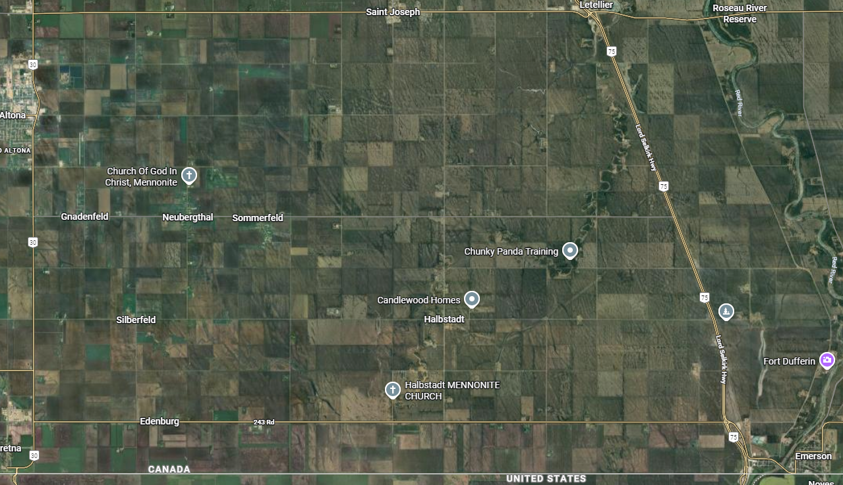
BRIDGE CLOSURE: January 12,2026 @ 8:00 AM until February 3rd,2026 @ 8:00 PM.
DETOUR
PR 243
PR 421

