

RURAL MUNICIPALITY OF MONTCALM
UNDER THE AUTHORITY OF THE PLANNING ACT
NOTICE OF PUBLIC HEARING
FOR CONDITIONAL USE ORDER NO. C2/24

On the date and at the time and location shown below, a PUBLIC HEARING will be held to receive representations from any persons who wish to make them in respect to the following manner:

APPLICATION FOR CONDITIONAL USE under the RURAL MUNICIPALITY OF MONTCALM ZONING BY-LAW 809/19,

HEARING: Council Chambers at the Municipal Office, 46 First Street East, Letellier
DATE & TIME: Wednesday, October 16, 2024 at 9:30 am
APPLICATION: C2/24
OWNERS: NuVision Commodities Inc.
APPLICANT: Nathan Sabourin
PROPOSAL: The applicant has requested a conditional use order to re-build and operate a Agricultural processing direct to rail facility.
AFFECTED AREA: 49 Elevator Rd, Lot 1 Plan CNR, St. Jean Baptiste, MB
BACKGROUND: The applicant is looking to re-build a direct to rail agricultural processing facility in the Town of St. Jean Baptiste in the MG Industrial General Zone- project entails conveyances and associated spouting, storage bins, rail loadout/support structures and truck loadout/support structure.

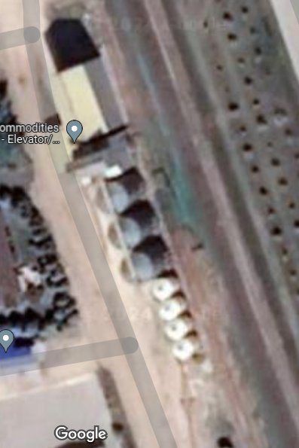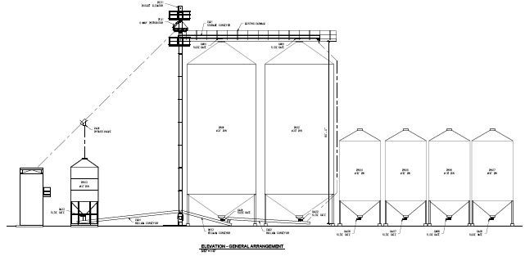
For further information, please contact Jolene Bird, CAO, R.M. of Montcalm, at
204-737-2271 or cao@rmofmontcalm.com

You are being notified as you are a landowner within 100 meters of the proposed property.

